Relational Databases with MySQL Week 4 Coding Assignment

**Points possible:** 70

|  |  |  |
| --- | --- | --- |
| Category | Criteria | % of Grade |
| Functionality | Does the code work? | 25 |
| Organization | Is the code clean and organized? Proper use of white space, syntax, and consistency are utilized. Names and comments are concise and clear. | 25 |
| Creativity | Student solved the problems presented in the assignment using creativity and out of the box thinking. | 25 |
| Completeness | All requirements of the assignment are complete. | 25 |

**Instructions:** Using a text editor of your choice, write the queries that accomplishes the objectives listed below. Take screenshots of the queries and results and paste them in this document where instructed below. Create a new repository on GitHub for this week’s assignments and push this document, with your Java project code, to the repository. Lastly, in the Learning Management System, click the “Add Submission” button and paste the URL to your GitHub repository.

**Coding Steps:**

Write 5 stored procedures for the employees database.

Write a description of what each stored procedure does and how to use it.

Procedures should use constructs you learned about from your research assignment and be more than just queries.

**Screenshots:**

This stored procedure sets the popularity of a last name. It takes in the employee last name, counts the number of occurences, and sets a popularity status of 100 or 0.

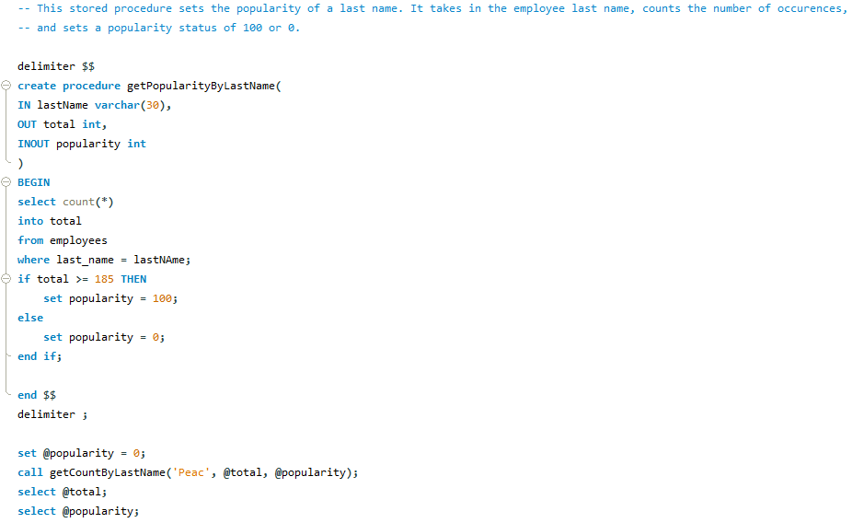

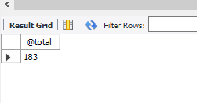

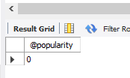

This stored procedure sets a tenure status for employees based on the number of years since hire date. It takes their employee number and evaluates their hire date to determine their tenure status.

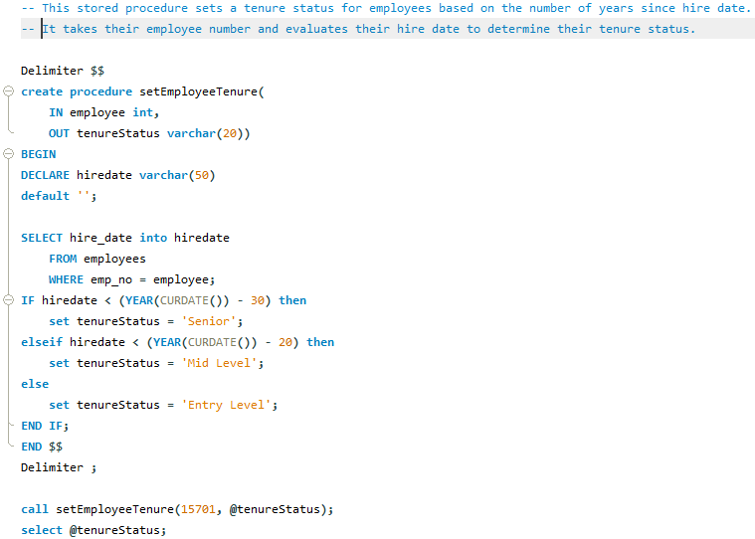

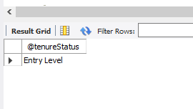

This stored procedure finds the number of employees in a particular department. It takes in the name of the department and uses the count function to then report the total number of employees in a particular department.

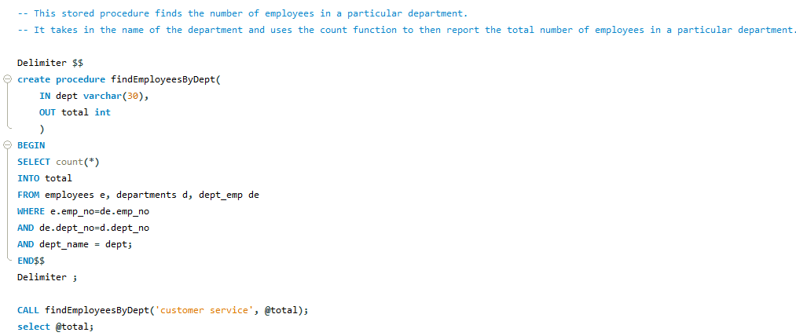

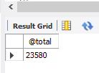

-- This stored procedure reports the number of vacation days for an employee based on their title. It takes their employee number, looks up their title, then determines how many vacation days they should have.

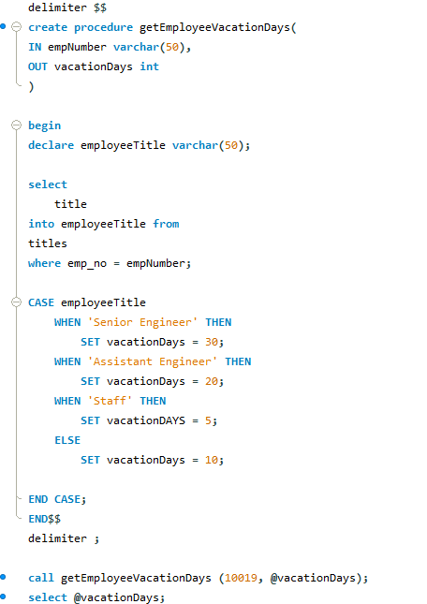

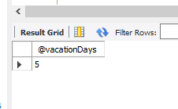

-- This procedure takes in a salary amount and returns a list of the titles that currently make that amount or more.

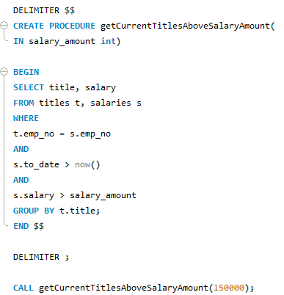

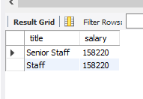

**URL to GitHub Repository:**

[**https://github.com/denisedayz/Week-10-Homework.git**](https://github.com/denisedayz/Week-10-Homework.git)